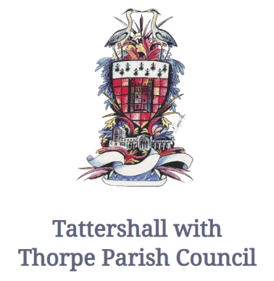
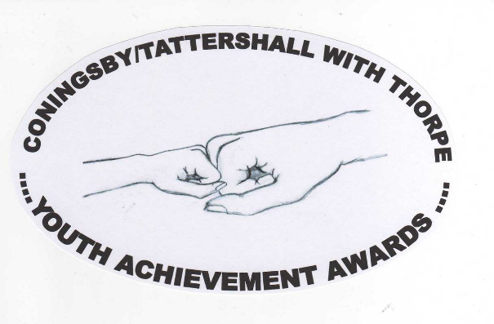

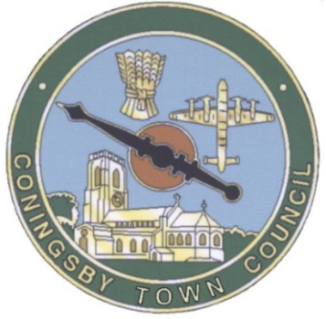
Nomination form
Coningsby / Tattershall with Thorpe Councils invite nominations for the 2026 Youth Awards; you can nominate a young person for any reason in either or both age groups and you can make as many nominations as you wish. Please use a separate sheet for each nomination. Example nominations: helping with shopping, walking dogs, visiting, being a carer, or fund raising. If you think you know someone worthy of recognition please nominate them and tell us why. Young people can nominate other young people.
Group 1. 0 – 11 years Group 2. 12 – 18 years
Your details
Name
Age
Address
Post code
Phone number
Relationship (if any) |  | to person you are nominating
Email address
 |  | Please tick this box if you would like your details kept confidential
Details of person you are nominating
Their name
Their age
Their address
Postcode
Their phone number
Email address
Please indicate if you wish any or all details to be kept confidential

Closing date for entries May 20th 2026
Entries to posted to: Coningsby Town Office, Coningsby, Lincoln LN4 4SG.
Emailed to assistantclerk@coningsbytowncouncil.gov.uk
Or Tattershall with Thorpe Parish Council, Troywood Farmhouse, Leagate Road, PE227SY
Emailed to:clerk@tattershallwiththorpe-pc.gov.uk
Please use the following section to outline why you feel the person deserves to be considered for this award.
All information received will not be used for any other purposes and will be destroyed once awards have been presented.
Signed -------------------------------------------------------------- Date ---------------------

